PC-6 Power Connector Kit Assembly Instructions
- Reminders and/or Warnings
  - Soldering irons, soldered joints, and traces are HOT and cool slowly. Don’t touch them…
  - Cut wires and component leads can be sharp, and can puncture or scratch – be careful.
  - Rosin smoke from soldering can be toxic, avoid inhaling or contact with it.
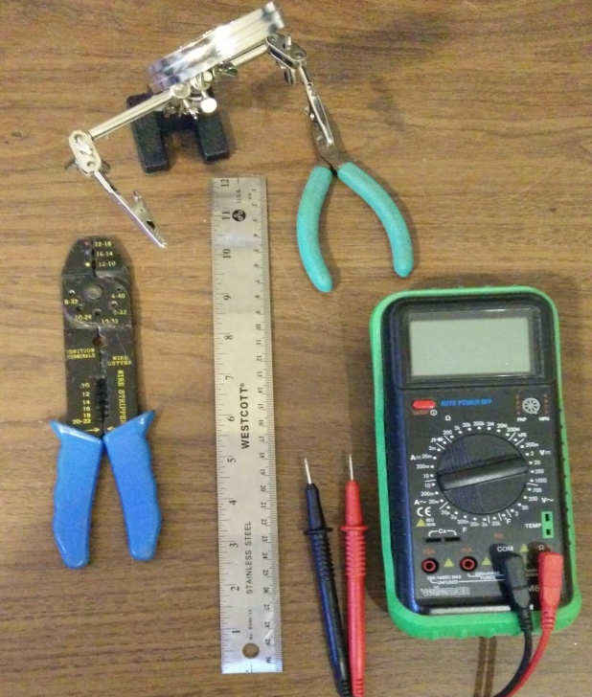
  - Lead-based solder can be harmful especially to kids – avoid contact and use caution.
- Prepare your assembly area.
  - Tools
    - Soldering Iron (A temperature-controlled soldering iron is highly recommended)
    - Rosin core solder
    - Wire Cutters (small, see photo)
    - Needle-nose pliers (not shown)
    - Crimper
    - Ruler
    - Ohmmeter or Multimeter
    - Vise, or alligator board holder
    - Ruler
    - 1/8” flat blade screwdriver
  - Eye protection is strongly recommended.
  - Get the board top and bottom diagrams out so you can see where the components go.
  - Get the schematic diagram out for reference.
Reference information can always be found online at www.K9JEB.com
- This is a bit more complicated kit to solder - but only because there are parts on both the top and bottom of the board, so following these instructions will be the key to success.
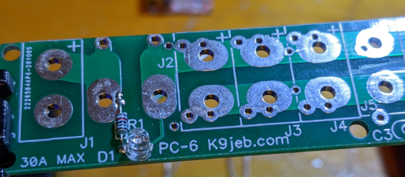
- Locate the schematic diagram, the assembly diagram, and the parts list on the website and have these handy for reference.
- Install and solder R1, trim
- Install and solder D1, trim the legs and save them for U1 later (if you have U1)
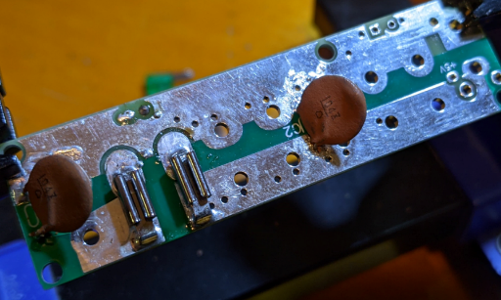
- Install and trim C3 and J8 (if using these)
- On the board BOTTOM side install and solder C1, C2, F1 mount holders. Be careful not to fill up the meter mounting pad (Pad 1) next to the fuse holder, they are very close together. Note that F1 connectors may be two pieces as shown, or as a single part with both.

- *** Read and understand the following few steps for installing the PowerPole and U1 before proceeding… U1 is on the bottom of the board and J5-7 are directly above it on the top. ***
- Assemble and install PowerPole connectors (see PP assembly section below), install and solder J7, J6, and J5 in that order. Be careful not to fill up the holes for mounting U1. Trim all PowerPole wires FLUSH to the board (this is easier if done before soldering them in actually).
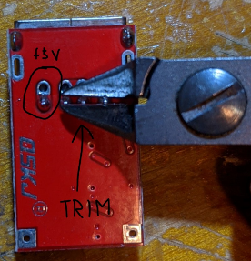
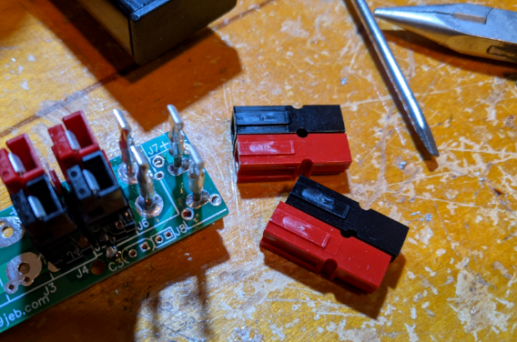
- Assemble U1 power input using the legs trimmed from D1 above. Tack-solder these in place as shown. Except for the +5V output pin, trim off the USB connector pins on U1 that stick through the board so they are flush to the bottom of the board. This is so it will sit flatter down on the PC-6. No tape or insulation needed on U1.
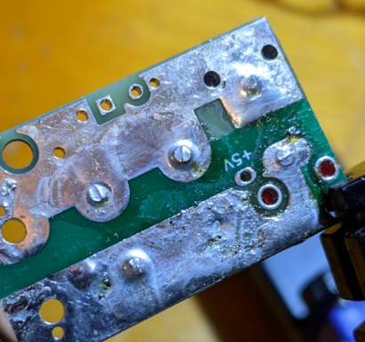
- On the BOTTOM side of the board, put U1 input power legs through the mounting holes near J5. Make sure the board is sitting completely level just over the PC-6 board, with about a 1mm gap between the bottoms of both boards.
- Tack-Solder the negative (ground) input power leg on U1 (next to C3), taking care not to melt J5. We will solder them all better, this is just to hold it basically in place while we perform the next steps. Next, we’ll remove the connectors shells on the top of the board so we can solder in U1 from the top of the board.
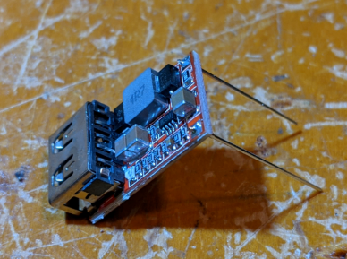
- Temporarily remove red and black shells on J6, J7. With a small 1/8” flat blade screwdriver, gently pry the PowerPole contact pin tongues up just enough so that they release from the shell. It doesn’t take much, so don’t bend the contact pin too much. Reach the screwdriver just under the tongue and push down the plastic just enough to lift up the contact tongue and release it. Wiggle off the two pairs of plastic shells so we can have space to solder in U1.
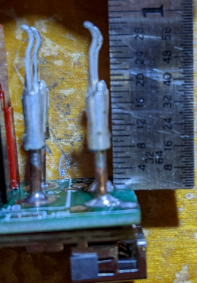
- Straighten back out the pins with some needle-nose pliers if they are bent up, otherwise they won’t re-snap back into the connectors later.
- [Use this step only If you are going to be using J8 to output power to another device] Make sure U1 is still level, and from the top solder the +5V in place, making sure enough solder flows from the top of the board through the plated hole, and through the bottom, attaching to the pin on the USB module which should be sticking a little bit through it, or close to it. Verify that the connectivity is good to the +5V now, or you won’t be able to fix it later when the PowerPole shells are reinstalled!
- Solder in the 4 USB shell ground connections, and the power and ground inputs from the top of the board, making sure to flow enough solder through the plated through holes. Make sure the shell ground joints are physically strong (they aren’t needed electrically) so they will keep the module attached to the board when people plug and unplug things from the USB port
- Reinstall J6, J7 plastic shell housings. Make sure the contact pins are straight enough to latch, and that they are still lined up with the plastic shells. They should just snap right back in nicely. If any of the pins were disturbed in the prior steps, re-solder them in place so that the barrel of the contact pin is exactly 9/32” (7.15mm) above the board, then they will be the right height to snap back in to the housings.
- Install J4, J3, J2, J1. Trim bottom legs if they are sticking out.
- [Kits with DVM] trim DVM leads to about 1.5” and solder black to “Pad 2” and red to “Pad 1” next to J2.
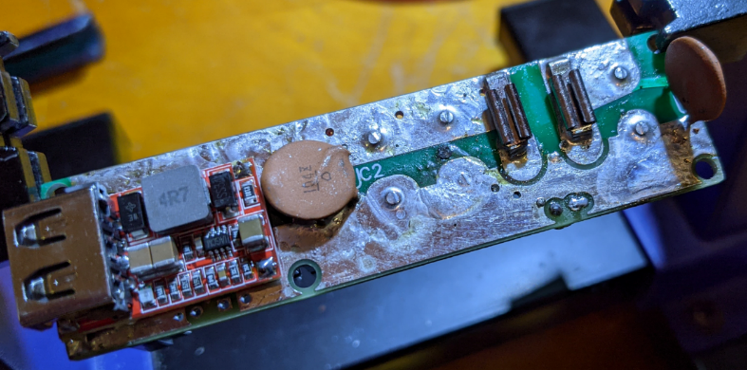
- Remove F1 fuse if installed, then insert into Deep Case and use 4 #2x1/4” flat head stainless steel sheet metal screws in the 4 mounting holes to attach. Snug but do not over-tighten – you’ll strip the hole out, it’s just plastic.
- [Kits with DVM] Slide left DVM ear in slot on case, secure right ear with M2x5mm flat head stainless steel screw, using the meter’s pc board hole as the “nut.” Do not over-tighten/strip.
PowerPole Connector Preparation and Mounting
Mounting the Anderson PowerPole connectors on the board requires some preparation
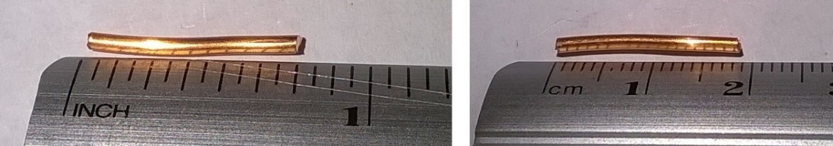
- Cut 14 pieces 5/8” to ¾” (16-19mm) from the bare copper wire (included), as shown.
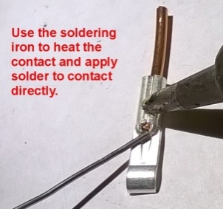
- Insert each wire segment into a PowerPole contact and crimp using the crimper, to hold it in place. Solder the tip of the wire with solder as shown.
- Join a red and a black PowerPole shell together by sliding them as shown in the picture. The standard connection is the “Red-Right-Tongue-Top” configuration (also referred to as “RRTT”). This ensures that your Power Pole connectors will be compatible with other equipment.
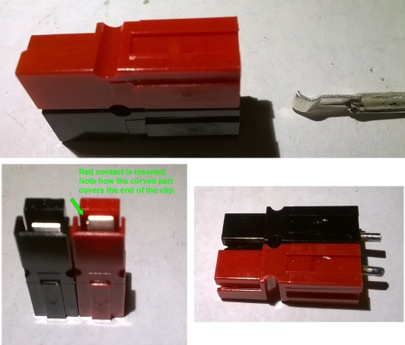
- Orient the contacts as shown in the picture and insert them into the Power Pole connector shells. The “curved” part of the contact will cover the spring clip inside the shell. Double-check your work against the pictures!!
- Mount the connector flush to the top of board with the red connector on the + side, and solder the + (red) side in place.
- Repeat process for each Power Pole connector.
- Cut all wires flush to board. Below is the finished assembly (PC51v2).
TROUBLESHOOTING
There really isn’t much that can go wrong with this simple board, but…
- Make sure there are no solder bridges between the + and – bus bars or there will be unpleasantness…
- If during first time testing, with power applied only to J1, a fuse blows for ANY REASON, immediately disconnect all of the power and equipment. Pull all of the fuses and check all connections with an ohm meter before connecting ANYTHING back to the board…
- Make sure that the Red connector and Black connector are on the correct sides as shown in the pictures, BEFORE soldering. It’s quite difficult to un-solder a connector that was constructed backward or sideways.
- Remove the fuse while power is connected and there is a load connected, the red Fuse Out LED should light. If it doesn’t, it may be reversed. Be careful when unsoldering LED’s and use low heat only or they will melt readily.
Email k9jeb@k9jeb.com with any questions (and pictures) if you need more help troubleshooting.

