- Reminders and/or Warnings
  - Soldering irons, soldered joints, and traces are HOT and cool slowly. Don’t touch them…
  - Cut wires and component leads can be sharp, and can puncture or scratch – be careful.
  - Rosin smoke from soldering can be toxic, avoid inhaling or contact with it.
  - Lead-based solder can be harmful especially to kids – avoid contact and use caution.
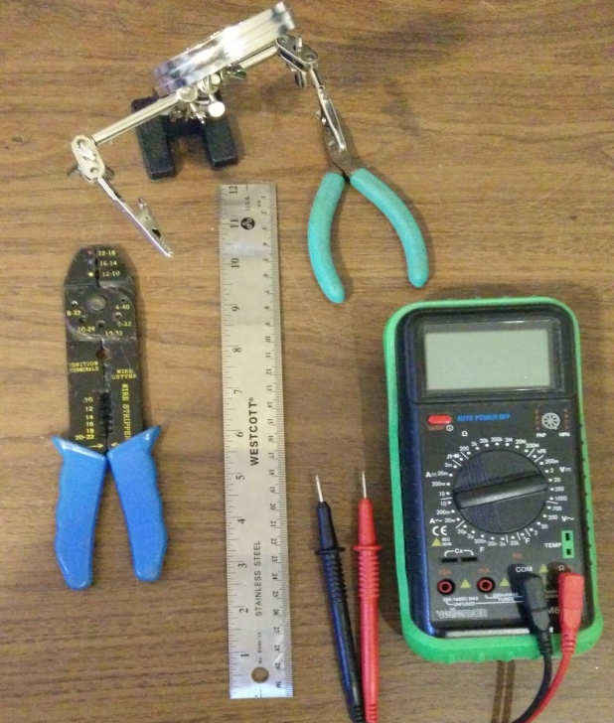
- Prepare your assembly area.
  - Tools
    - Soldering Iron (A temperature-controlled soldering iron is highly recommended) at 340-350°C
    - Rosin core solder 60/40 Lead-Tin 0.020” or 0.32”
      - Such as Kester 44 1/32” dia or smaller
    - Wire Cutters (small, see photo)
    - Needle-nose pliers (not shown)
    - Crimper
    - Ruler
    - Ohmmeter or Multimeter
    - Vise, or alligator board holder
    - Ruler
  - Eye protection is strongly recommended.
  - Get the board top and bottom diagrams printed out so you can see where the components go.
  - Get the schematic diagram out for reference.
- Separate the parts into groups (e.g. resistors, LED’s, etc.) so you’ll know where they are when you need them. We’ll need resistors and LEDs first, then the capacitors, then the fuse holders and finally the wire and PowerPole connectors.
- Note that on the boards up to and including V5.02a – the D1 Master fuse-blown LED was shown backward in the old schematics and the board. The + (long leg) side of the LED goes to the resistor NOT the “+” as shown on the board – or else it will never work when F1 fuse is blown or removed.
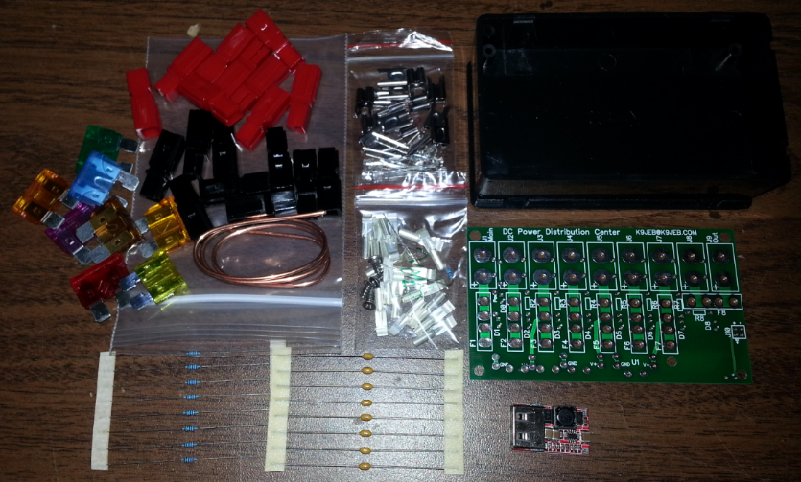
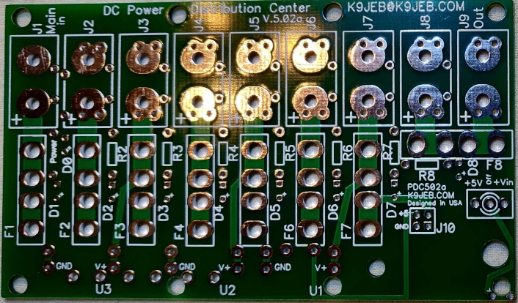
- Version 5.02a of the board:

Now… Let’s Get Started!
Reference information can always be found online at www.K9JEB.com Refer to the board top and bottom layout diagrams on the website. I print out the schematic and layout of the top and bottom of the board. Make sure to use the version of the schematic/layout that matches your board. Note that these pictures below may differ slightly from yours.
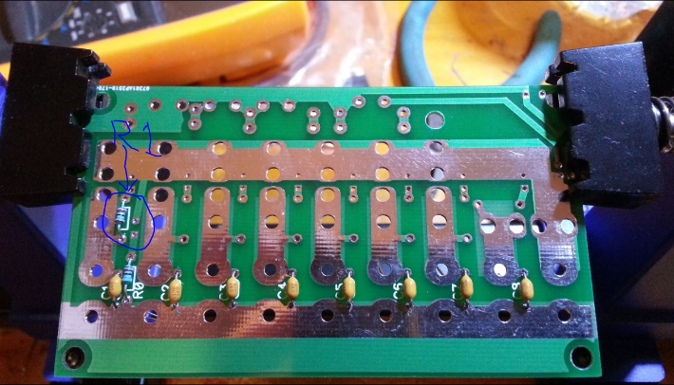
- Overall the process is to mount first the fuse holders, then the lowest-profile parts like the resistors and LEDs first and then the taller ones, such as the PowerPole connectors, later.
- Complete the Fuse Socket Contact Preparation and Mounting procedure below.
- On the bottom of the board mount resistors R0 and R1, and all of the capacitors C1-C8. Capacitors may be optional on your kit.
  - Resistors and these capacitors aren’t polarized, so it doesn’t matter which way they go in. Make sure that R0 is the 56K (Green-Blue-Orange), and R1 is 10K (Brown-Black-Orange) – circled in Blue
  - Bend the resistor and capacitor leads close to the body so they point straight down then put the leads through the holes and seat the component down all the way to the board as shown
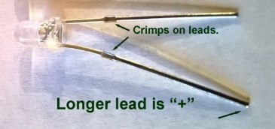
- Mount R2-R8 on the top of the board.
  - Tack-solder the resistors in place so they make electrical connection.
- If on the bottom side, flip the board back over to the top side.
- Mount Green Power LED D0 on the top of the board and tack-solder in place from top. Insert up to the crimp, or mount flush to the board – which ever you like best.
- Mount the indicator LEDs D1-D8 on the top of the board (some may be optional) and tack-solder in place. NOTE: D1+ is labeled backward on the board – the + side of the LED actually goes to the resistor R1, NOT to the “+”.
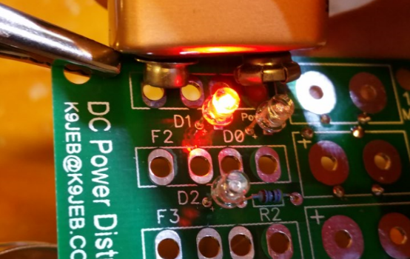
- It’s advisable to check each of the LEDs to make sure the polarity is correct and they light up, before soldering them in place… The picture shows one way to do this for red LEDs with a 9V battery.
- Avoid testing any LED without a resistor in series – it’ll burn out the LED.
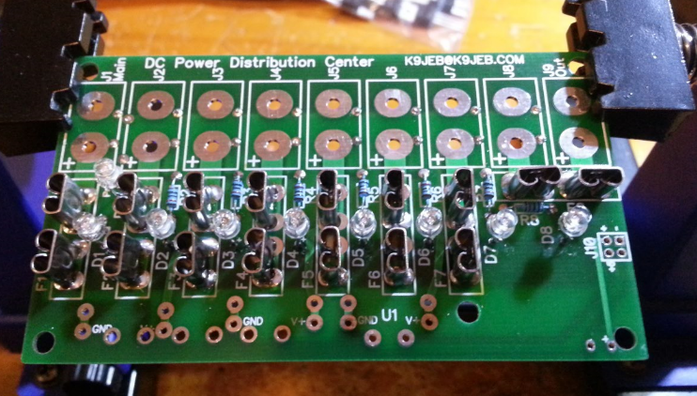
- Be sure that the resistors are in place and touch the battery terminals to the pads for J1 (if the F1 fuse is installed, or with jumper leads to J1- and F1 lower) and verify the green Power LED lights up. If it doesn’t, the LED is mounted backward.

- Use the battery with + terminal on the left and – terminal on the right where the fuses mount as shown (or use the same pads on the bottom of the board) and check the red LEDs for polarity also.
- Flip the board over to the bottom side and trim off all of the leads about 1/32” (1mm) above the board, or just so they barely stick out past the board.
- Finish soldering all the resistor and LED components in place.

- Complete the PowerPole Preparation and Mounting procedure below.
- If you require total maximum current carrying capacity over 30A, you may wish to complete the optional Heavy Duty Power Bus procedure below.

- Insert fuse F1 (main) and test the board.
  - Connect a 12V DC supply using an Anderson PowerPole connector to the “Main” connector input J1
  - Power LED should light up green.
  - Use a Voltmeter (or the DVM) to verify power presence and correct polarity for the other PowerPole connectors.
  - Note that J9 (Out) is a direct connection to the main fuse, so it will have power as long as the main fuse is in place.
  - To test the “blown fuse” LED indicators, you need to provide a load on each branch output (J1-J8). If you have a load (like a radio or other device), plug it in. Another way is to create a “mock” load with a small value (below 1k Ohm) resistor by putting the leads into the red and black connectors (they only need to make loose contact for testing).
  - Pull the fuse for the output you are testing. The associated LED should light. If it doesn’t, skip to the Troubleshooting section to understand what the problem is before proceeding!

- If you purchased the optional USB charging module or other optional DC power module, refer to the DC Power Module Installation instructions segment.
- If you purchased the optional Digital Voltmeter, refer to the Digital Volt Meter Installation instructions segment.

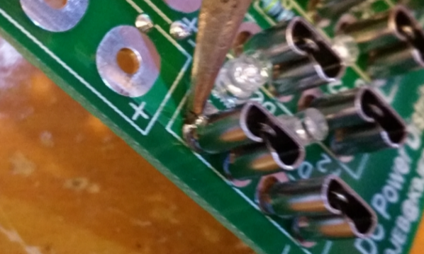
Fuse Socket Contact Preparation and Mounting
- Mount each pair of fuse holder sockets on the top side of the board, with the open side to the left as shown. Push the connectors down to the surface of the board as flush as they will go.
- Using 60/40 lead-tin rosin core solder 0.020” or 0.032” dia., Tack-solder them in on the top of the board similar to those as shown by the arrows. Make sure to heat it enough that the solder adheres to the connector, but don’t burn the board. Make sure each of the connectors is straight, and oriented as desired.
- Flip the board over. Make sure each connector is straight. Solder in each of the fuse holders, one leg at a time. Make sure to connect each leg to its pads with enough solder to make a good connection as shown. Avoid using too much solder, as it will flow down to the top side of the board, and excess may clog the clip that holds the fuse blade.
- Flux on the board as seen here can be cleaned off with Flux Remover after assembly is completed.
- Make sure there is a gap between the fuse holders, and no solder short there.
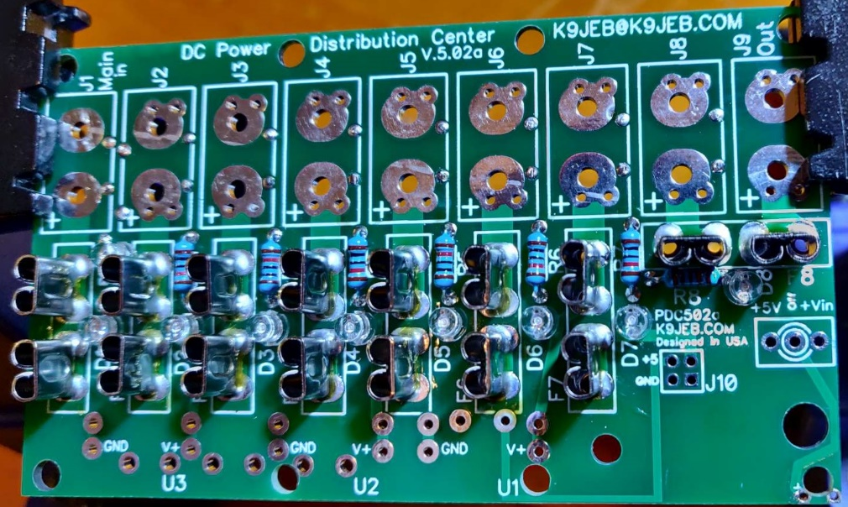
- The main power bus and ground traces can be coated completely with extra solder – this is not required, but does increase total current carrying capacity to about 35A.
- This picture is what the board should look like at this stage. Now continue on to preparing and installing the DVM.
- On V5 boards there is a toggle switch for the DVM mounted next to it, solder it in after the DVM is in place, from the bottom of the board.
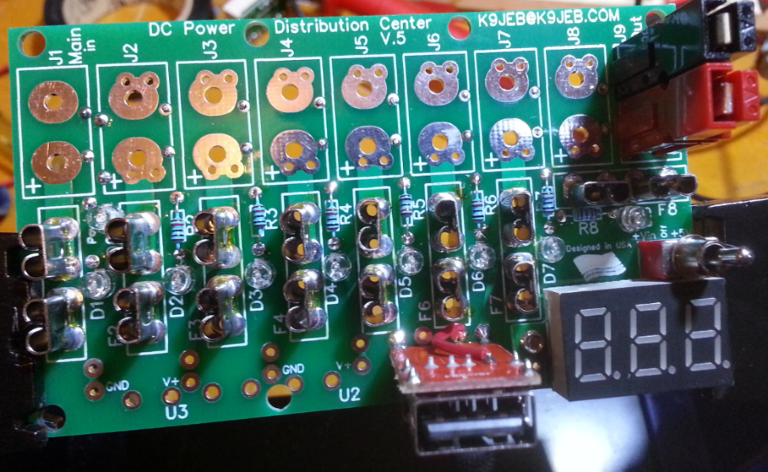
- If you want the +5V from the U1 USB module to be monitored on the DVM, wire its output to the pad nearest the V+ on U1.
Sample photos of assembly in progress after soldering in DVM, one PowerPole connector and USB module

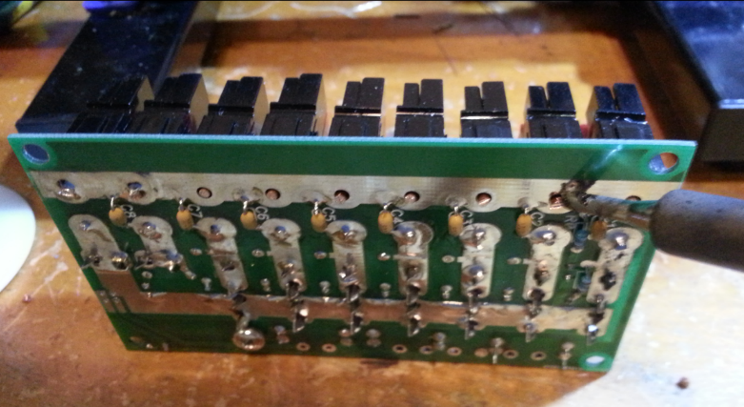
Soldering in the ground side of the PowerPole connectors (next page)
PowerPole Connector Preparation and Mounting
Mounting the Anderson PowerPole connectors on the board requires some preparation
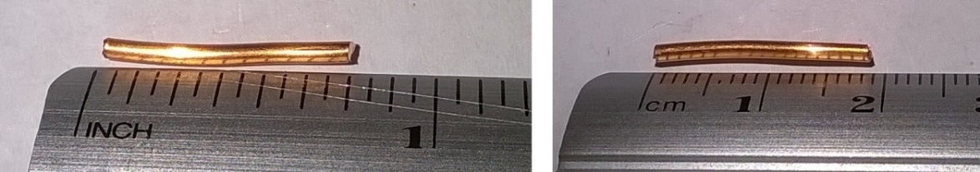
- Cut 18 pieces (if you have all outputs) 5/8” to ¾” (16-19mm) from the bare copper wire (included), as shown.
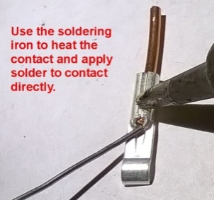
- Insert each wire segment into a PowerPole contact and crimp using the crimper, to hold it in place. Solder the tip of the wire with solder as shown.
- Join a red and a black PowerPole shell together by sliding them as shown in the picture. The standard connection is the “Red-Right-Tongue-Top” configuration (also referred to as “RRTT”). This ensures that your PowerPole connectors will be compatible with other equipment.
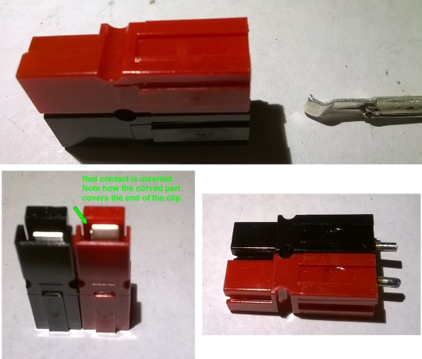
- Orient the contacts as shown in the picture and insert them into the PowerPole connector shells. The “curved” part of the contact will cover the spring clip inside the shell. Double-check your work against the pictures!!
- Mount the connector flush to the top of board with the red connector on the + side, and solder the + (red) side in place.
- If using the High-Current wire bus option, leave the ground side (black) connector un-soldered for now. If not, make sure the connectors are all straight on the board, and solder these in place also.
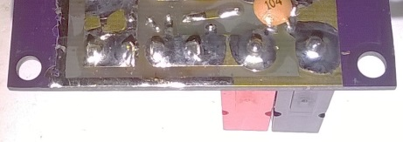
- Repeat process for each PowerPole connector J1 thru J9.
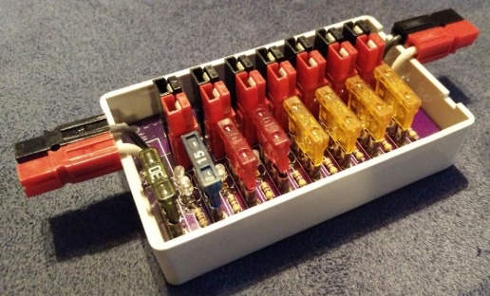
NOTE: You may optionally wish to use longer (and insulated) solid wires for input J1 and output J9 so you can orient them horizontally for daisy-chaining multiple boards, as shown. The 15A pins work with #14AWG solid copper, for #12AWG, use 30A pins.
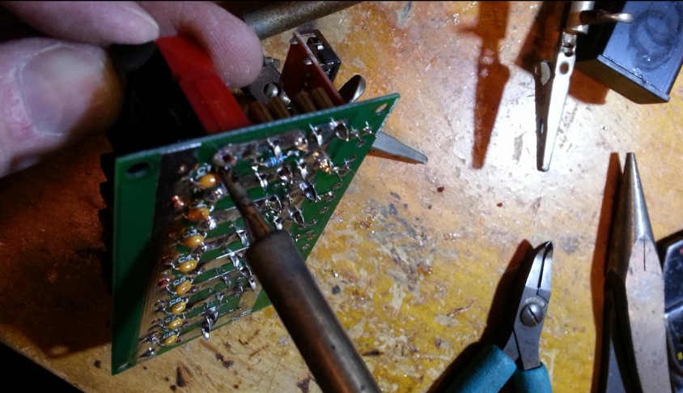
- You may also wish to install the optional header pins in J10 as shown in the picture.
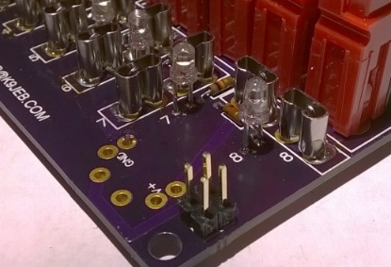
(Note that the pictured purple board is a prototype only – yours may look different.)

DC Power Module Installation
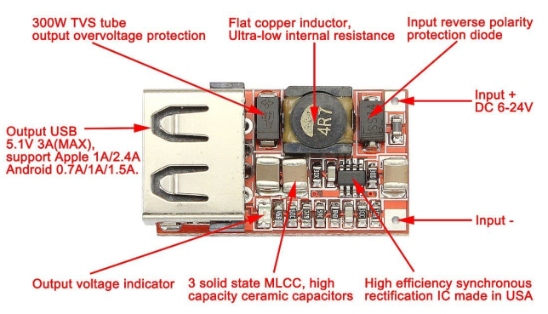
If you ordered one of the DC power modules such as the USB charger or buck converter, this section will show how to install it. Here are the diagrams of some of the modules for reference:
- USB Module (can be installed on board)
  - Note the inputs + and – above. There is a polarity protection diode, so installing it backward won’t damage it – but then it won’t work either…

- Adjustable DC-DC Converter Module (off-board use)
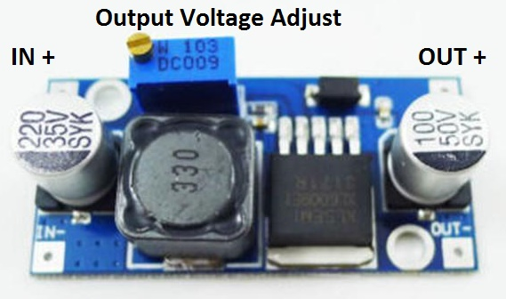
  - Note the + and – inputs, there is no input polarity protection so be sure to install it correctly. Output must be fused externally at 3A to protect the circuit also. There is NO reverse protection diode.
  - IN- and OUT- are both tied together, and need be connected to ground on the board.
  - (old) Picture may vary from your newer model. Some also have constant-current CC settings.

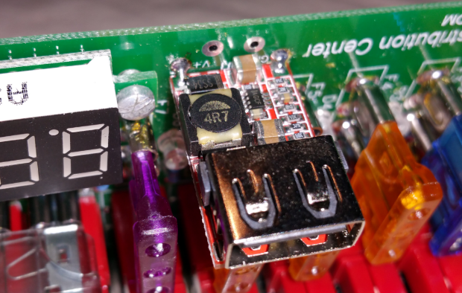
- Use the cut leads from one of the resistors to loop through the module inputs in an inverted U shape. These provide both the electrical and physical module mounting. If you need +5V wired in, use one of the meter lead wires to attach to the terminal on the back of the module as shown below.
- Feed each of the leads into the two holes for IN- and IN+ on the board
- Tack solder the leads to the board inputs to hold them in place.
- Tack solder the board’s leads in place on the top side, orienting the board and holding it in place. Be careful to observe the correct polarity before soldering.
- Solder in the +5V wire to the pad nearest it as shown in the picture below.
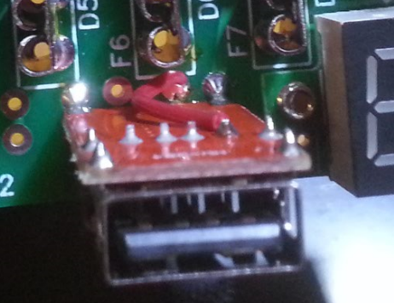
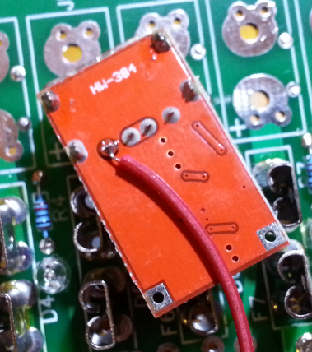
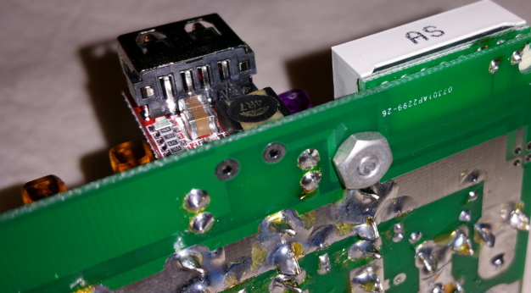
- Solder in place and completely flow solder through the board and module inputs.
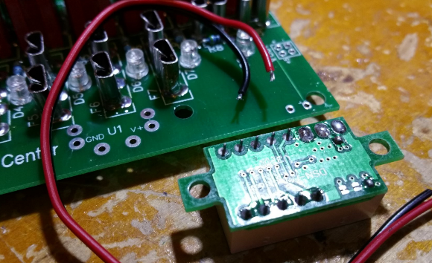
Digital Volt Meter Installation (pre-5.02a Version)
- If the DVM is going to be mounted on the circuit board and the circuit board is going to need to fit in the project box, the right mounting loop on the DVM board needs to be cut off, or else it will stick out preventing the board from going into the box.
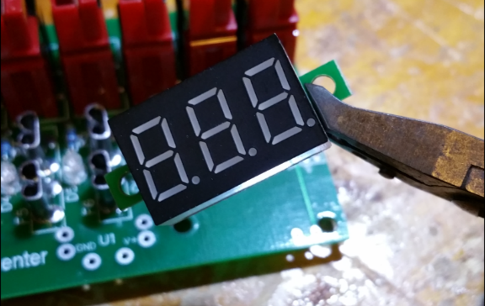
- Suggested mounting is on a piece of double-sided tape, a 3/8” #6-32 screw (not included). Shown below with just the screw, and no tape. I use a 6-32 tap to “tap” the mounting hole in the meter, this provides enough friction that I don’t need a nut.
- Prepare the DVM by clipping the two meter wires to about 3/8” long and pull off the insulation.
- If the right mounting ear is to be removed, clip it off with wire cutters, and file the edge of the DVM board so that it’s flush.
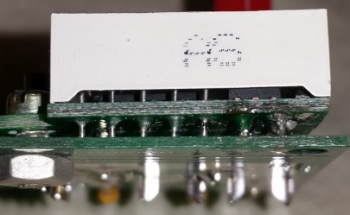
- Stick/bolt the meter to the board with the wires through the tiny drilled holes (not necessarily the pads).

- You may need to twist and tin (slightly) the stranded wires so that they go through the holes. You may need to bend them over on the bottom of the board from the holes to reach the pads.
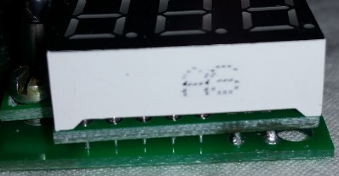
- Solder the two wires in place on the board and make sure not to melt the solder or disconnect the electrical contacts at the back of the meter board.
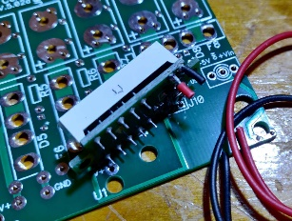
(Note - These photos are from a prototype – not the best soldering job, and the DVM board is a little crispy.)
Board Version 5.02a and later with 0.28” DVM:
- The DVM meter leads must be folded flat (toward each other) so the meter is flat to the board, otherwise the included M2.5x5mm screw will not reach the meter. Solder the meter first, then screw in.
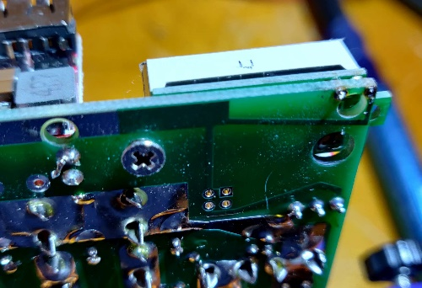
- Follow item 6 above, clip and tin the meter wires about 3mm long, but do not apply much solder or they won’t go through the tiny holes in the corner of the board. You may want to remove the wires from the meter and solder directly to the board pads.
- Screw in the M2.5x5mm screw gently into the left meter ear, but don’t strip. It should be held well in place with just the solder and the screw. Clip off the right tab even with the board or it won’t fit in the box.
- The new meter has a small potentiometer on the back that will allow adjustment if needed. Be careful not to short out pins on the meter board if adjusting it with a metal tool.
Augmenting the DC Power Bus for Higher Current
Note: we recommend attempting this procedure ONLY with a high-power temperature regulated soldering iron and prior soldering experience / skill. 14AWG should be OK to 40A, 12AWG for up to 45A MAX (the max for PowerPoles).
- This additional wire will increase the current carrying capacity to a total of 40A (perhaps up to 60A)
- To enhance the current carrying capacity of the distribution board, additional solid copper wires (optional) are soldered on the bottom of the circuit board for the three main current carrying traces.
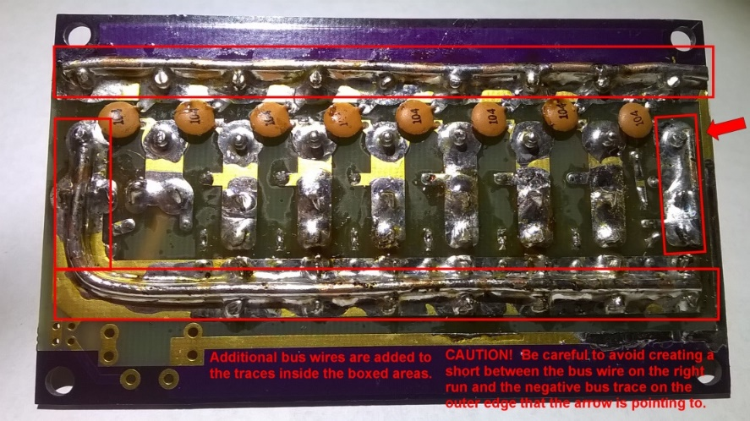
  - Ground trace (top)
  - Main Bus distribution trace (bottom, L-shaped)
  - Input trace (right, with arrow)
- The 3 bus wires will be soldered to the bottom of the board at the locations shown in the picture.
- Cut pieces of solid copper wire and form them to fit the 3 large copper traces as shown. Cut and shape them to their final shapes so you can handle them easier during the tack soldering process.
- Lay the ground wire across the ground trace (black connectors) and tack-solder it to the circuit board on each end. First, flow solder across the wire between each of the ground connector legs, then the connectors.
- When soldering these, note that the trace, board, and connections already in place will be hot for some time, be careful not to touch them.
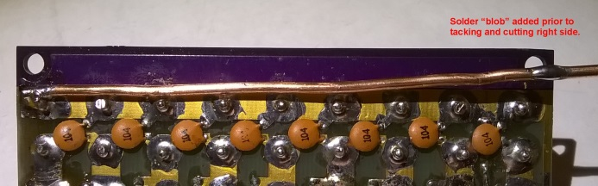
- Repeat this process for all three bus wires. Don’t overheat the traces or they could lift off the board.
- Add some solder to tin the trace on the bottom of the board between the fuse holder and the PowerPole connectors also. There are traces on both sides of the board, but this will help share the current here too. Be careful not to get solder into the fuse holder tabs on the top side, or the fuse won’t be able to go in.
- For high-current use it is also recommended to use 30A or 45A PowerPole pins, and 12AWG solid copper wire for each connector.
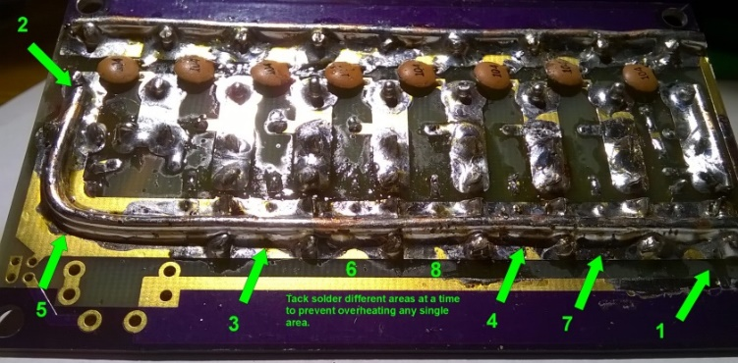
- Be careful though if you do run high current through this board, its only safety features are fuses.
TROUBLESHOOTING
In the event “something” isn’t working quite as expected, here are a few ideas about how to figure out the root cause of the problem and correct it.
- If during first time testing a fuse blows for ANY REASON, immediately disconnect all of the power and equipment. Pull all of the fuses and check all connections with an ohm meter before connecting ANYTHING back to the board…
- Make sure that the Red connector and Black connector are on the correct sides as shown in the pictures, BEFORE soldering. It’s quite difficult to un-solder a connector that was constructed backward or sideways.
- Make sure the LED lamps are oriented with the correct polarity. The long leg of the LED is the + side. There is a small + silk screened on the board that should match the long leg. I recommend testing each before soldering in place, just to make sure.
If something does burn out or releases the “magic blue smoke…” Let me know and I’ll see if I can get you replacement part(s) for a reasonable (or free) price + shipping.
Email k9jeb@k9jeb.com with any questions (and pictures) for troubleshooting.

