- Reminders and/or Warnings
  - Soldering irons, soldered joints, and traces are HOT and cool slowly. Don’t touch them…
  - Cut wires and component leads can be sharp, and can puncture or scratch – be careful.
  - Rosin smoke from soldering can be toxic, avoid inhaling or contact with it.
  - Lead-based solder can be harmful especially to kids – avoid contact and use caution.
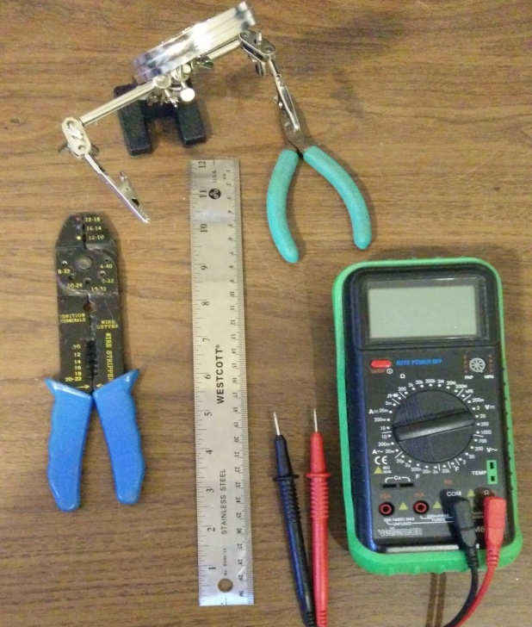
- Prepare your assembly area.
  - Tools
    - Soldering Iron (A temperature-controlled soldering iron is highly recommended)
    - Rosin core solder
    - Wire Cutters (small, see photo)
    - Needle-nose pliers (not shown)
    - Crimper
    - Ruler
    - Ohmmeter or Multimeter
    - Vise, or alligator board holder
    - Ruler
  - Eye protection is strongly recommended.
  - Get the board top and bottom diagrams out so you can see where the components go.
  - Get the schematic diagram out for reference.
Reference information can always be found online at www.K9JEB.com Refer to the pictures below of the PC-4 version board and finished kit. Note that these pictures may differ slightly from yours. PC-5 v2 has 2 capacitors C1 and C2 (not shown in assembly photos).
Top 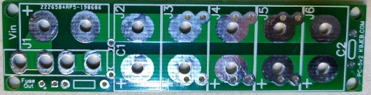 Bottom 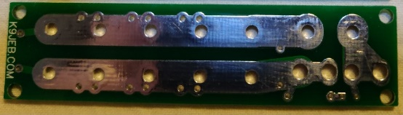
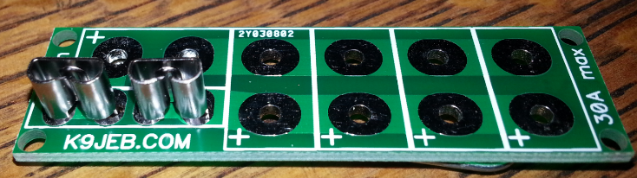
- Overall the process is to mount the fuse holders first and then the PowerPole connectors second.
- Fuse holder sockets go above the website address on the top of the board as shown above.
(old board version)
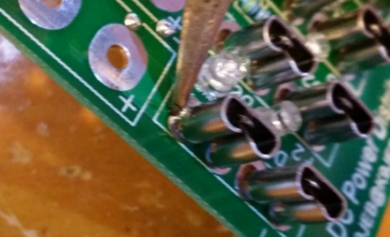
- You must use rosin core solder, and a temperature of about 340°C in order to melt the solder and get it to adhere to the nickel coated brass contacts. If you don’t – it won’t
- Mount the pair of fuse holder sockets on the top side of the board, with the open side to the left as shown. Push the connectors down to the surface of the board as flush as they will go.
- Tack-solder them in on the top of the board similar to those as shown by the arrows. Make sure to heat it enough that the solder adheres to the connector, but don’t burn the board. Make sure each of the connectors is straight, and oriented as desired.
- Flip the board over. Make sure each connector is straight. Solder in each of the fuse holders, one leg at a time. Make sure to connect each leg to its pads with enough solder to make a good connection. Avoid using too much solder, as it will flow down to the top side of the board, and excess may clog the clip that holds the fuse blade.
- Make sure there is still a gap between the fuse blade holders, and no solder short there.
- Fuse Out indicator – mount the 10K resistor and solder in place, then mount LED with longer lead in “+” hole as indicated on board.
- Solder in optional USB module(s) using the instructions from the Power Distribution Center.
  - NOTE: If you mount two or more modules next to each other, you must put a spacer/insulator (I use double-sided tape) to keep the +5V pin from one module from shorting out on the grounded outer shell of the connector behind it.
PowerPole Connector Preparation and Mounting
Mounting the Anderson PowerPole connectors on the board requires some preparation
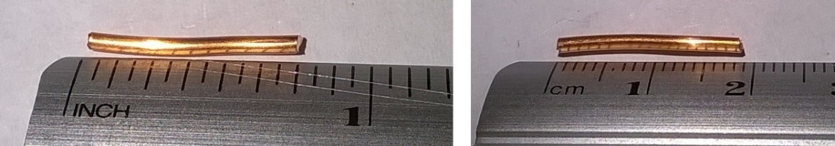
- Cut 10 (or 12) pieces 5/8” to ¾” (16-19mm) from the bare copper wire (included), as shown.
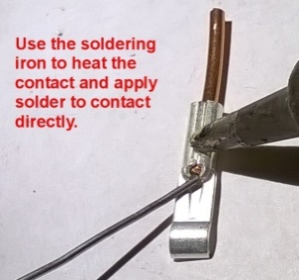
- Insert each wire segment into a PowerPole contact and crimp using the crimper, to hold it in place. Solder the tip of the wire with solder as shown.
- Join a red and a black PowerPole shell together by sliding them as shown in the picture. The standard connection is the “Red-Right-Tongue-Top” configuration (also referred to as “RRTT”). This ensures that your Power Pole connectors will be compatible with other equipment.
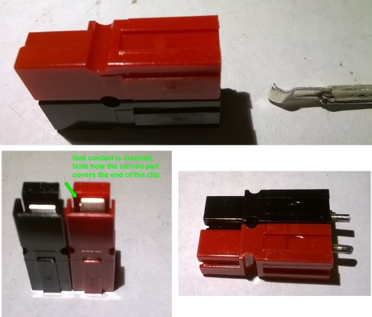
- Orient the contacts as shown in the picture and insert them into the Power Pole connector shells. The “curved” part of the contact will cover the spring clip inside the shell. Double-check your work against the pictures!!
- Mount the connector flush to the top of board with the red connector on the + side, and solder the + (red) side in place.
- Repeat process for each Power Pole connector.
- Cut all wires flush to board. Below is the finished assembly (PC51v2).
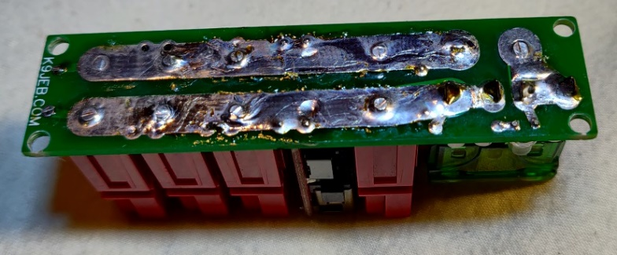

Short 3-D Printed Cases

If needed – mount the case to a mounting surface with M5 or #10 flat head screws (not included). Do not use round head, pan head or other types of screws - these may cause a direct short if they touch the board… If there is any concern about a short, or in any case less than 0.1” (2.5mm) clearance between the board contacts and the screw heads – please use a strip of electrical tape over the screw heads to avoid a catastrophic short circuit! Make sure also that the PowerPole connector wires are cut flush to the board.

If you have a 3D-printed case, use the 4 #2 FH stainless steel screws provided to secure the board to it in the 4 corners. Do not over-tighten or you will strip out the plastic… They don’t need to be any tighter than snug just to keep the board from jiggling when you shake it.

For the short DVM Case version, please put the DVM’s red and black leads through the case FIRST and THEN solder them to the back of the board… Solder Red to + and Black to – anywhere on the bus, or use the USB module mounting holes if you prefer. Once they are soldered in, then use 2 of the 6 provided #2 FH stainless steel screws to mount the meter to the case. Then, if needed – mount the case to the mounting surface with M5 or #10 flat head screws. Finally use the 4 remaining provided screws to attach the board to the case last.

Deep 3-D Printed Cases
Use a long #1 Phillips screwdriver vertically upward to put each mounting screw on the tip, then hold the case and board upside down to bring the board/case to the screw on the screwdriver tip then tighten (but don’t overtighten).

For the DVM Deep Case version, omit or remove C2 (unless you have a USB module, then instead leave C2 installed and use holes the PowerPole would have used). Trim the DVM leads to no more than ½” (13mm) longer than needed to reach the board. Use the board holes for connecting the power and ground from the DVM and solder in from the top of the board. Mount the board and then slide the meter into the slot on the case on the top left. Guide the wires for the meter inside the case down and away from the PowerPole connectors, then use the M2.5x5 Flat Head screw from the outside front of the case to mount the meter to the case. Be careful not to strip the board’s hole – it doesn’t need much to keep it in place.

- TROUBLESHOOTING
There really isn’t much that can go wrong with this simple board, but…
- Make sure there are no solder bridges between the + and – bus bars or there will be unpleasantness…
- If during first time testing a fuse blows for ANY REASON, immediately disconnect all of the power and equipment. Pull all of the fuses and check all connections with an ohm meter before connecting ANYTHING back to the board…
- Make sure that the Red connector and Black connector are on the correct sides as shown in the pictures, BEFORE soldering. It’s quite difficult to un-solder a connector that was constructed backward or sideways.
- Remove the fuse while power is connected and there is a load connected, the red Fuse Out LED should light. If it doesn’t, it may be reversed. Be careful when unsoldering LED’s and use low heat only or they will melt readily.
Email k9jeb@k9jeb.com with any questions (and pictures) if you need more help troubleshooting.

