Power Transfer/Charger Kit
PTC110 and PTC122 Versions

Summary Description
This circuit is designed as a battery transfer and charger circuit that fits on top of a 9Ah SLA (Gel/AGM) lead-acid battery. It will take input from a regulated power supply at 13.8V and distribute it to up to 5 output connectors (unfused). The board can carry up to 30A for distribution and up to 15A continuous usage from the battery. Power is connected through world-standard Anderson PowerPole connectors. The circuit is designed to connect the battery both when there is power coming in, and charge the battery up to just below the input power voltage. When external power is removed, the battery switches in to the circuit through a very low resistance MOSFET to provide power to the equipment attached to the outputs, without interruption – similar to an online UPS for AC. There is also an adjustable over-voltage cutoff circuit that will disconnect the battery from power in the event external power goes over the set limit, protecting the battery from over-charging. The board comes with 1 but supports up to 3 2.5A USB Charger module ports, with access to the +5V supply output on an optional header connector J6. The DVM measures the input/output voltage, or the battery voltage, or can be turned off completely. The battery is also switchable so that it can be isolated from the power if desired.
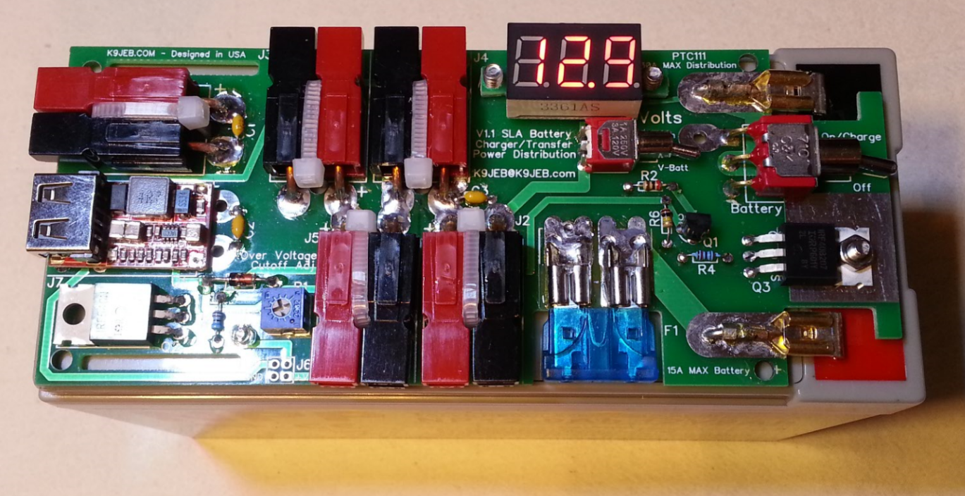
Notes Before you Begin:
This board has been through several revisions and has literally dozens of working units in the field. That being said – there’s always room for improvements! Please send all feedback and suggestions to K9JEB@K9JEB.com. If you have something unexpected, troubleshooting help will be best effort through email.
Sometimes things get missed… Please make sure you have all the parts before assembly! Let me know if not.
Note that your board may not look exactly like the following pictures – they are for reference only.

Parts List (V1.13)
B1 SLA: 7-12Ah
C1, C2, C3 0.1uF
D1 1N4738A 8.2Vz
D2 LED Green
*D3 10A10 10A rectifier diode (optional, only in V1.12 and higher)
F1 15A
J1, J2, J3, J4, J5, (J7) PowerPole
J6 Header, 2x2 (optional)
M1 DVM
Q1 2N3906 PNP
Q2 IRF540N MOSFET N-channel Enhancement
Q3 IRF40B207 MOSFET N-channel Enhancement
R1 1k Trimpot
R2 1k 1/8W (brn-blk-red)
R3, R4 10k 1/8W (brn-blk-org)
R6 100k 1/8W (brn-blk-yel)
S1 sub-micro toggle On-Off-On
S2 mini toggle On-On
U1(U2, U3) USB Module

Assembly Instructions
The pictures are of the 1.11/1.13 versions – the V1.22 board has more outputs and a little bit different layout. The connectors can have a vertical or horizontal configuration as needed by the builder. Adapt instructions accordingly.
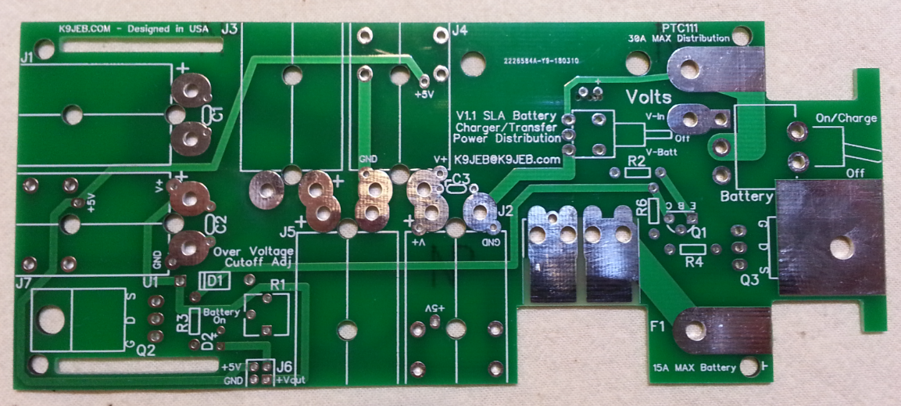
- Identify all parts in the kit and where they go on the board. If anything is missing, stop and send email first.
- Crimp the brass lugs around about ¾” length of copper wire and bend to fit between the battery and your board for first the negative terminal. The wire should come all the way up to where the flat part was curled around to make contact with the battery tabs – almost 3/8”. The lugs are kind of weak, so don’t bend them too much or they’ll break off – and that’s a problem. Solder it in place for the negative terminal, then do the same for the positive terminal. See the pictures. If you got rubber insulators for the terminals, install them when cool.
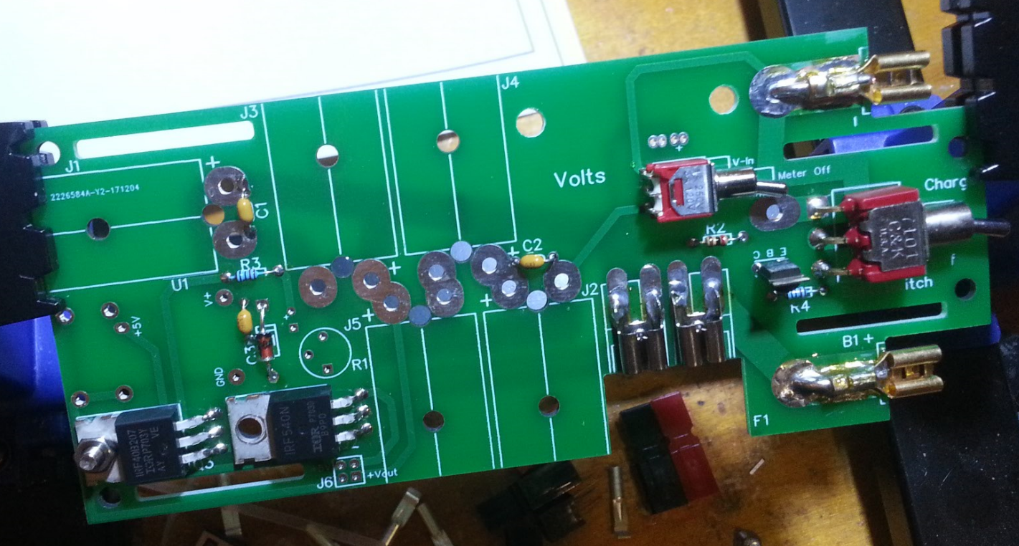
- Not all battery contacts are 1.75” centers (as I found out) so your connectors will be placed more or less to fit your battery. There is more than adequate slack on both sides for this.
- Make sure the lugs line up to the actual battery terminals before soldering in place – it’s hard to unsolder it and move it after the fact. It should be ok to connect them to the actual battery – nothing is on the board yet, and no fuse.
Prototype board shown in assembly photos – newer boards are like the previous photos.
- Mount and solder in the capacitors, resistors and Zener diode, these are low profile and won’t get in the way of soldering other components. Keep the clipped leads from the caps to use for V+ and GND on USB module.
- Solder in both switches.
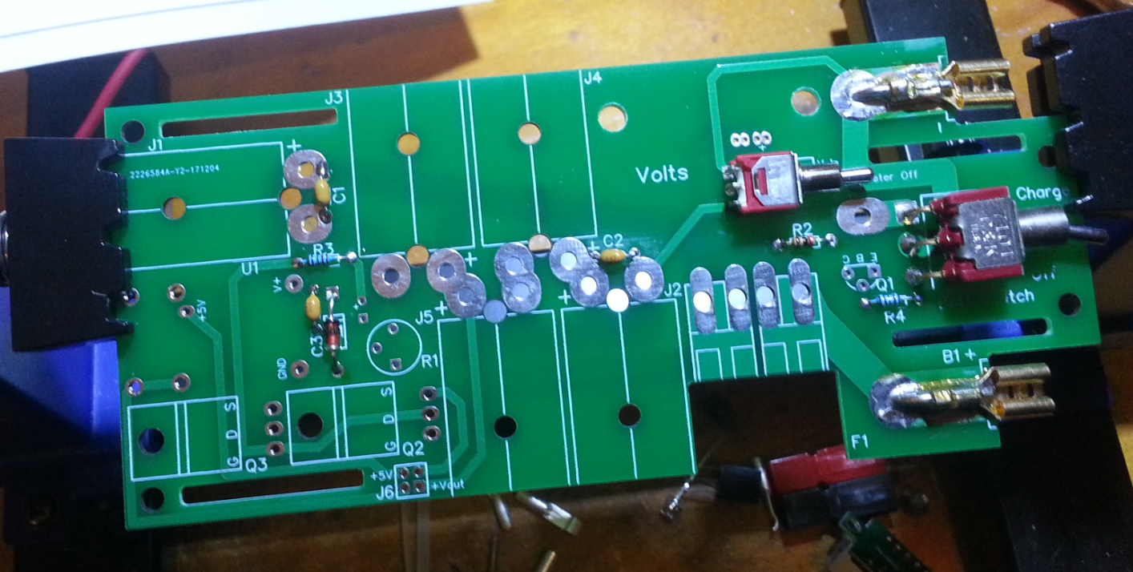
- Solder in the fuse holders for F1. Place them gently on the fuse and tack solder them in place with the fuse in place (but don’t melt the fuse), then remove the fuse and finish soldering them fully. Solder in Q1, keep it very close to the board so it doesn’t stick up and get squished.
- Solder in Q3 and then Q2. Make sure that the hole in the board lines up with the transistor before soldering, and for Q3 add thermal grease (if desired) on the back of the transistor before soldering. Use the M3 screw and nut on Q3 to ensure heat transfer to the board. Q2 does not need a screw or grease.
- First test, then solder in the LED also about 1/8” off the board. Use low heat as quick as possible as these melt quick. Carefully observe polarity! These are impossible to unsolder and flip.
- Solder in the U1 USB module using leads clipped from the capacitors vertically through the V+ and GND inputs. Then solder the ground contacts at the edge of the board to hold it in place (they aren’t needed electrically). If you need +5V out on J6, solder in the +5V contact through the plated through hole on the bottom of the board - otherwise you might want to leave it out.
- Solder in the trimpot R1.
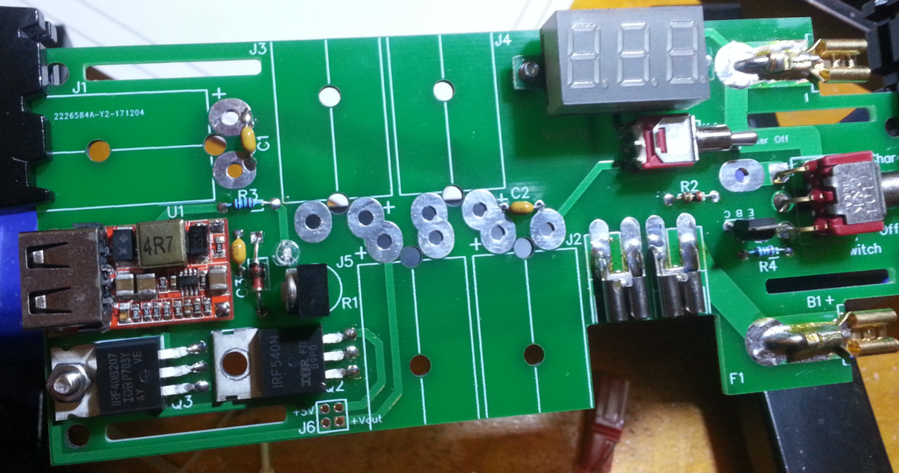
- Prepare the Digital Voltmeter [DVM] by unsoldering the wires, they are not used. Use M2.5x5 screws into the holes in the meter ears, which are enough to hold it in place. Don’t screw in too tight or strip the meter ears and solder in place first, then tighten the screws gently. Solder all the way through from the back side of the board so the solder flows through the holes and fuses with the meter contacts. Test the meter by switching the switch to Vin and applying voltage to J5, confirming the meter works.
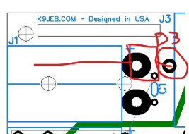
- If using D3 on J1 as input – use the diode itself instead of the copper wire for the positive terminal. Crimp and solder the powerpole contact pin to the diode lead itself, so that the diode body is just about 1/8” past the connector housing when the pin is installed. Solder the other leg of the diode into the hole specifically for this purpose as shown (do not use the large hole):
- Cut 7/8” (22mm) segments of wire for the horizontal-oriented connectors and crimp and solder on each of the PowerPole contact pins. I solder from the bottom, some people solder from the top. Either way, just make sure it’s got a good solder flow. For the V1.22 MAX – there are both vertical power poles and horizontal ones – the vertical ones use 5/8 wire segments.
- Assemble the PowerPole shells sliding red up into black, with red on right with them pointing Away from you. See pictures if any questions, double check if unsure. Then check again... don’t get this backward…
- Insert the contact pins into the PowerPole shells, and bend them with pliers or other tool to fit into the holes on the board, matching the connectors’ hole with the hole in the board. You might want to align the connector to the board by inserting a ty-wrap to align it. Solder each in place and ty-wrap the horizontal connectors in place (when cool) to secure them to the board.
- Inspect the board and make sure there are no solder bridges or shorts.

Testing/Adjustment
- All voltage measurements mentioned are with reference to Ground – the negative (black) side of Vin/out and *NOT* the battery “–“ terminal…
- Install F1 fuse, use a low amperage one if you have it - 3A or less for testing.
- If anything goes wrong pull the fuse and/or disconnect it from the battery. But hey – what could go wrong??
- Switch battery Off with the battery switch.
- Switch meter to Battery – it doesn’t matter if the battery is on or off.
- The meters typically read high by 0.1 to 0.2V in the 13V range, and they are not adjustable sorry.
- Touch board contacts to battery terminals briefly, meter should light up and flash, then read battery voltage.
- If anything else happens… stop here and use a multimeter to find the problem. Otherwise continue.
- Switch meter switch to Vin, turn battery on – this will energize the circuits. USB module should come on, and you should see +5V on J6 if you connected that pad.
- Assuming all looks good, switch meter back to Battery.
- Turn the trimpot all the way CCW this should set the gate of Q2 to 0V and turn off the OV circuit.
- Connect a 13.8V power supply to any PowerPole connection, if it’s charging you should immediately see the battery voltage start to rise and the green LED should be on.
- If you can, turn the power supply voltage up to about 14.1V and adjust R1 Clockwise until the LED just dims and goes off indicating the Over-Voltage clamp Q2 has been activated. Now any voltage over 14 should not charge the battery, and adjusting it back down to 13.8 or lower will release the clamp, charge the battery and keep the green LED on.
- If your power supply doesn’t adjust, turn R1 clockwise until it just dims out, then turn it back CCW a little bit just so it comes on full. This will set the cutoff voltage just above the current input.
- Switch the meter back to Vin and disconnect the external power, the battery should continue to power the meter and anything connected to the PowerPole connectors.
- Green LED is on whenever the battery is connected to the outputs – charging or powering the load.
- To turn off the battery completely switch off S2, and switch meter to Vin to avoid the 15mA drain of the DVM.

Note: Up-to-date schematics and drawings are available on the website K9JEB.com – but may not be as up to date here embedded in this document.
Schematic (see website for latest versions)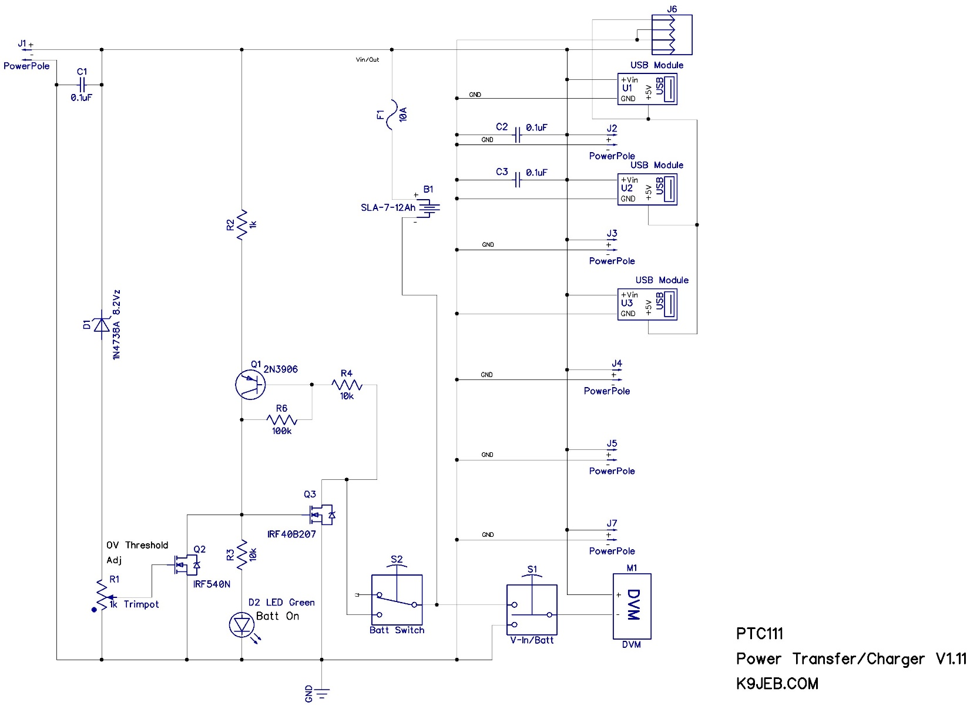
Top Layout (see website for latest versions)